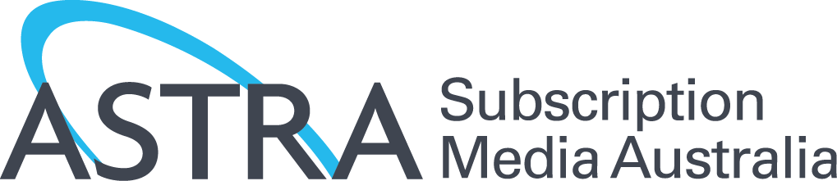

ANTI-SIPHONING
April 2015

KEY POINTS

- The public policy intention of the ‘anti-siphoning’ scheme is to ensure free-to-air (FTA) broadcasters have an opportunity to acquire broadcast rights for sporting events of national importance or cultural significance.
- The scheme prohibits subscription television (STV) licensees from acquiring broadcast rights to listed events unless a FTA broadcaster has first acquired them.
- Australia’s anti-siphoning list – at more than 1000 events – is the longest and most draconian in the world. It includes international events which are not similarly regulated even in their host country.
- The anti-siphoning provisions directly limit competition between FTA broadcasters and STV for a wide range of sports content, shifting the balance of negotiating power in favour of FTA networks.
- The rules reduce the amount of sport on television and starve sporting codes of the revenue they need for grassroots activities and business development.
- ASTRA proposes simple reforms that would retain the public policy rationale of the scheme while introducing greater competition for sports broadcast rights.

Regime limits competition and harms investment

The anti-siphoning provisions directly limit competition between FTA broadcasters and STV for a wide range of sports content, shifting the balance of negotiating power in favour of FTA networks.

From a practical perspective, the current regime enables the FTA broadcasters to act as ‘gatekeepers’ to all broadcast rights for listed events. This supresses competition and reduces the price for the rights, thus reducing the income sports bodies receive and the amount of funds that they can invest in local, grass roots sporting and community initiatives.

One of the problems with the anti-siphoning scheme is that it treats sport as a public service, instead of multi-billion dollar entertainment businesses with a responsibility to monetise assets, recoup costs, pay players and officials, develop their businesses and reinvest in sport at the grassroots level.

The scheme also artificially limits choices for consumers, many of whom are now seeing the value in subscription sports services, which offer more coverage, innovative new features and deeper analysis. The price for watching premium broadcasts of Australian sport is declining, not increasing. A cable subscription with dozens of entertainment channels and premium sport costs less today than a year ago, and direct online subscriptions to the football codes are available from as little as $3 a week.

Australia’s regime the world’s most draconian

While some other countries have restrictions, Australia’s anti-siphoning list – at more than 1000 events – is the longest and most draconian in the world. It includes international events which are not similarly regulated even in their host country. The current list includes events that could not reasonably be regarded as having national importance and cultural significance to Australians, including the English FA Cup Soccer Final, the US Masters golf tournament, the US Open tennis tournament, and Twenty20 Cricket.

ASTRA proposes a shorter list

ASTRA proposes simple reform of the anti-siphoning list that would retain the public policy rationale while introducing greater competition for some sports. Key national events which are truly of significance to Australians will stay on the list, whilst some limited delistings would deliver more choice to sporting organisations to decide how their rights are sold and how their events are televised.

